Introduction 2

Installing & Running ACAD 2

Basics of the ACAD Application 2

Key Buttons 2

Help Prompts 3

Data Entry Tabs 3

Entering Numerical values 4

Entering Text 4

Selection Values 4

Airfoil Files 4

Preview Tabs 5

Viewing the Example Files 6

Designing a Wing 7

The Design Flow 7

Coordinate System 7

Planform Coordinates 7

Z or Height Coordinates 8

Lightening Holes 8

Defining the Planform 9

Airfoil Definition 10

Building a Wing Upside Down 11

Defining Ribs 11

Geodetics 12

Rib Parameters 13

Washout 13

Trailing Edge Thickness 14

Keepouts 14

Spars 14

Elements (Tubular and Rectangular Bar) 16

Sheeting Jigs 16

Alignment Dots 17

Leading Edge Templates 18

The Example F3A Wing 18

# Introduction

ACAD is a tool for accelerating the design of model aircraft parts.

Presently, it provides features for the design of “built up” model aircraft wings.

The licenses and copyright ACAD is distributed under is covered in the Licenses\licenses.txt file in the application’s install directory.

# Installing & Running ACAD

ACAD is a 64-bit Windows application and requires Windows 10 or later to run.

To install ACAD, download and run the windows installer acad_installer.exe. This will install ACAD on your computer.

To run ACAD:

1. Click the windows Start Button
2. Select the Acad folder
3. Click the ACAD icon

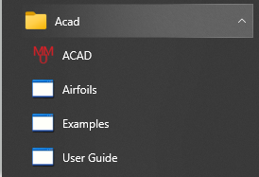

# Basics of the ACAD Application

## Key Buttons



In the top left of the window are the key buttons of ACAD. In order, they are:

1. The “NEW” button. Click this button to start a fresh wing design; if the current design has not been saved since the last change, you will be prompted to save it first.
2. The “OPEN” button. Click this to open a previously saved wing design; if the current design has not been saved since the last change, you will be prompted to save it first.
3. The “SAVE” button. Click this to save the current wing design to file; if you haven’t yet specified a file name, you will be prompted for one.
4. The “SAVE AS” button. Click this to save the current wing design to a new file with a different name.
5. The “BUILD & EXPORT to HPGL” button. Click this to build your wing in high resolution mode and export the drawings to a HPGL plot file.
6. The “BUILD & EXPORT to DXF” button. Click this to build your wing in high resolution mode and export the drawings to a DXF drawing file.
7. The “Draft Previews” check-box. When checked, the “Plan” and “Parts” tabs will display a slightly lower accuracy rendering of the parts (albeit still accurate to 0.1mm!). This helps keep the program running quickly on slower computers.

## Help Prompts

In-application help is available by hovering your mouse over an item. After a second or so, any help that is available will pop-up. Some examples are shown below:

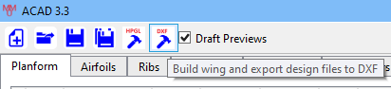

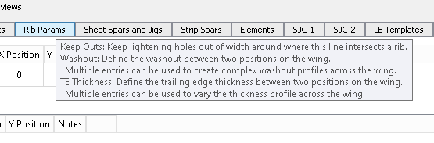

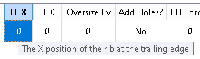

## Data Entry Tabs

In the ACAD window, you will see a series of data entry tabs. Each of these has the same layout.

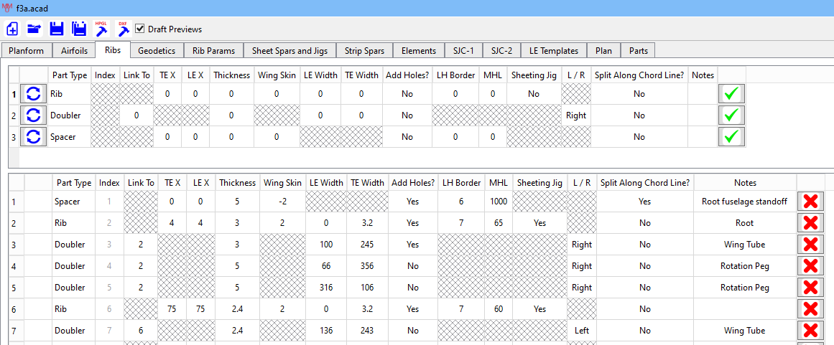

You can also edit values in model parts after they have been added

Click this button to delete the part from the design

Design parts are shown here

Click this button to add the part to the design

Click this button to reset the entry data

Enter the data for new parts in this section

### Entering Numerical values

Numerical values are entered in one of two ways:

* You can type the value directly into the table after selecting the square
* You can click the up/down arrows to increment the value



### Entering Text

Text values, such as the notes column, are entered directly after selecting the square.



### Selection Values

Some values are to be chosen from a set of options. There are a few ways to do this:

* Double click the square and use up/down arrow to step through the options.
* Double click the square and use your mouse scroll wheel too step through the options.
* Double click the square and then click the down arrow to see all the options.

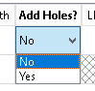

### Airfoil Files

On the Airfoils tab, double clicking the Airfoil File square will open a file dialogue box. In here, you can select the .dat file for the airfoil you want to use. The software supports Selig and Lednicer format .dat files.

If you want to use the option to invert the airfoil, make sure to set this *before* you select the airfoil file.

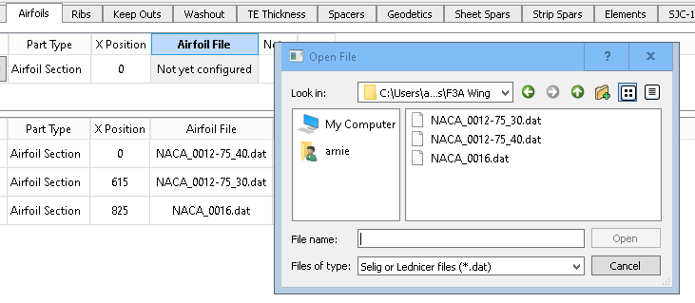

A small set of symmetrical and asymmetrical airfoils are provided with ACAD. They can be accessed via the shortcut in Acad start menu entry:



## Preview Tabs

As you progress through a design, you will want to view the plan of the wing and the parts you are creating. You do this in the “Plan” tab and the “Parts” tab. When you select one of these tabs, ACAD will generate the wing plan and the parts you have defined so far and display the results.

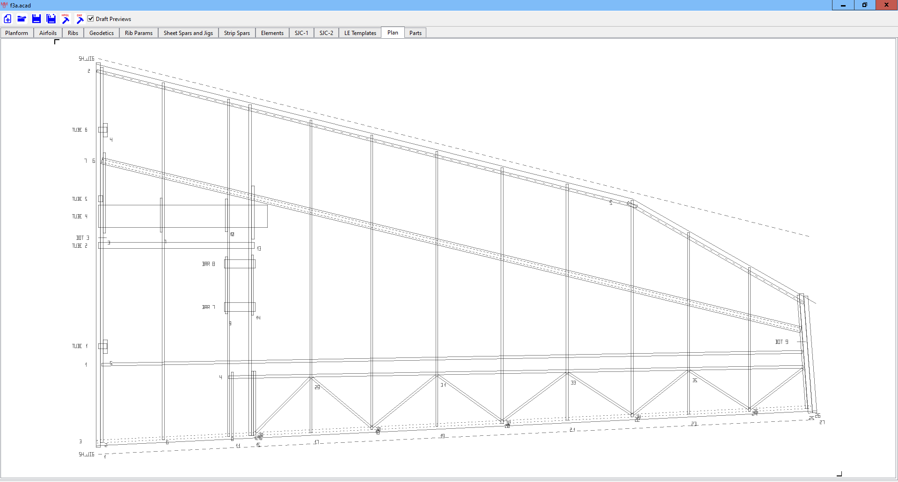

Once in the Plan or Parts tab, you can:

* Zoom in or out on the mouse position using the mouse scroll wheel
* When zoomed in, left click and drag the drawing around
* Perform measurements:
  + Right click once to start a measurement. As you move the mouse, a dotted line will trace from the start point to the mouse pointer. The bottom left of the window will show the (x,y) coordinates of the mouse pointer.

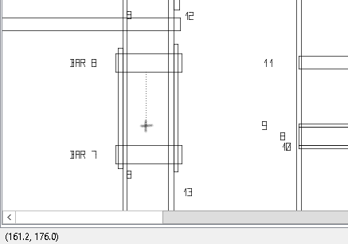

* Right clicking a second time will finish the measurement. The bottom left will now show the measurement results.

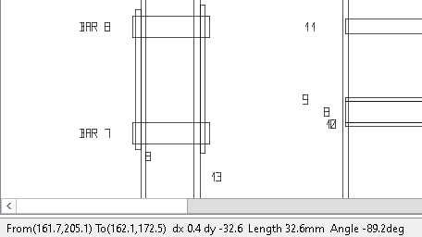

# Viewing the Example Files

A couple of example files are provided which demonstrate how to use ACAD to design a wing.

To look at an example, start ACAD and click the open button. The file dialogue will open in examples folder of the Acad application. 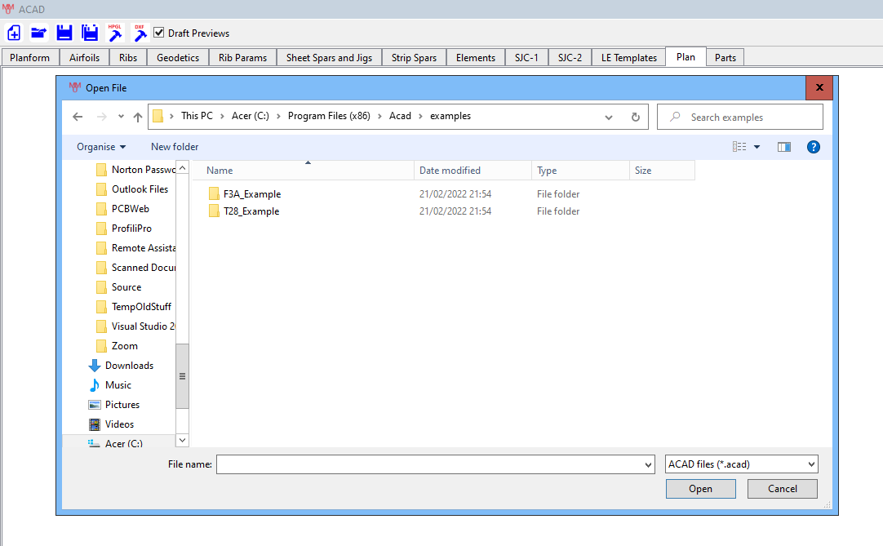

Open the folder of the example you want to look at.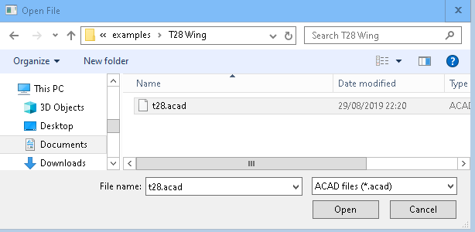

Select the .acad file and click open.

# Designing a Wing

## The Design Flow

1. Sketch out the planform of the wing and decide where all the ribs, spars, tubes, blocks etc. will go. It is useful to do this to scale on a sheet of graph paper or using a basic 2D CAD package.
2. Decide on the airfoil sections in the wing. As a minimum, you will need a root airfoil section and a tip airfoil section (which may be the same).
3. Download from the internet, or generate using a package like Profili, a .dat file for each airfoil section. ACAD supports both Selig and Lednicer format files.
4. Translate your sketch into a design using the features provided by ACAD. Typically, you will do this by working through the ACAD entry tabs left-to-right.
   1. Planform definition
   2. Airfoil definition
   3. Rib and spacer placements and definitions
   4. Geodetic rib placements
   5. Rib parameters such as washout, trailing edge thickness and manual slot keepouts
   6. Sheet spar and jig definitions
   7. Strip spar definitions
   8. Tube and bar section elements
   9. Wing sheeting jig definitions
   10. LE radius templates

## Coordinate System

### Planform Coordinates

The majority of wing components are specified by their positions in the plan view of the wing, using “x” and “y” coordinates. A good strategy to adopt is shown in the figure below:

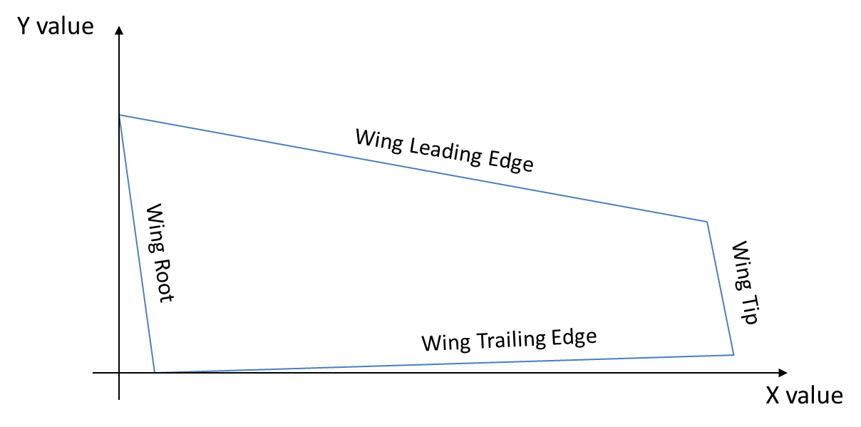

The wing root is placed at the left, with the leftmost point at X=0. The trailing edge is at the bottom, with the lowest point at Y=0. You can imagine that the Y axis points along the line of the fuselage and this is the right-hand wing panel.

### Z or Height Coordinates

Where it is necessary to specify a height for a component, there are usually three options provided:

|  |  |
| --- | --- |
| **Relative to the Chord Line** | The Z value will be interpreted as an offset from the airfoil chord line. A positive value will place the item above the chord line, a negative value below the chord line. |
| **Snap to outer** | The object will be snapped to the rib outline and then moved by Z towards the chord line. |
| **Snap to outer and rotate** | As for “snap to outer”, but the object will also be rotated to align with the rib outline. |

## Lightening Holes

For many elements, ACAD can automatically add lightening holes. In order to do this, you specify two parameters for the part:

* Lightening Hole Border Width (LH Border). This is effectively the minimum amount of material to be left between the outer edge of the part and the lightening hole.
* Maximum Hole Length (MHL). Elements intersecting a part, such as spars or tubes, create regions where holes are excluded. ACAD will attempt to place holes between these regions; if this results in a hole which is longer than MHL, it will be split into two or more holes of length less than MHL.

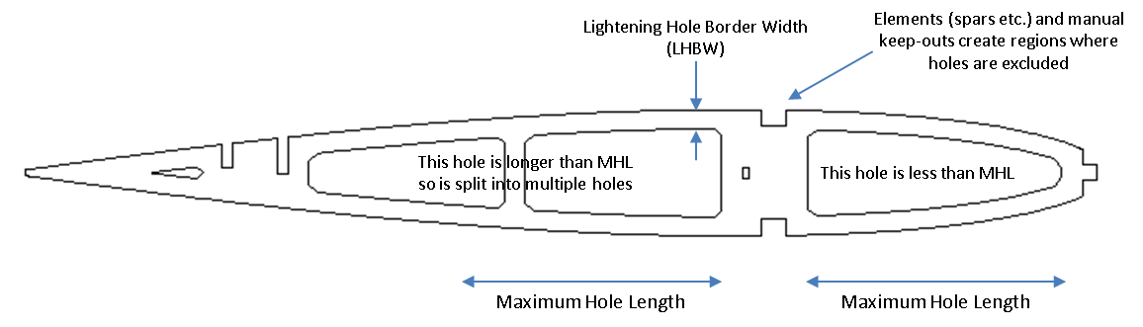

For ribs, the *keepout* parameter (Rib Params tab) can be used to exclude holes from a region(s) of one or more ribs.

## Defining the Planform

To define the wing planform, the leading and trailing edge positions are defined using a series of points.

Let’s take the F3A wing as an example:

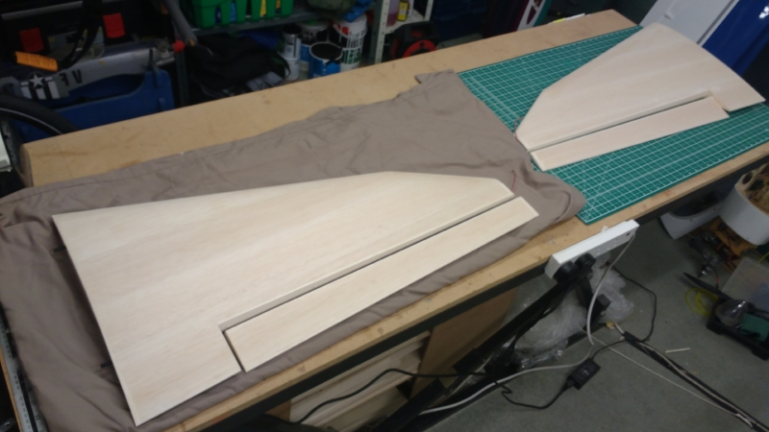

The planform for this wing was sketched out and then captured for ACAD as follows, using the standard coordinate scheme:

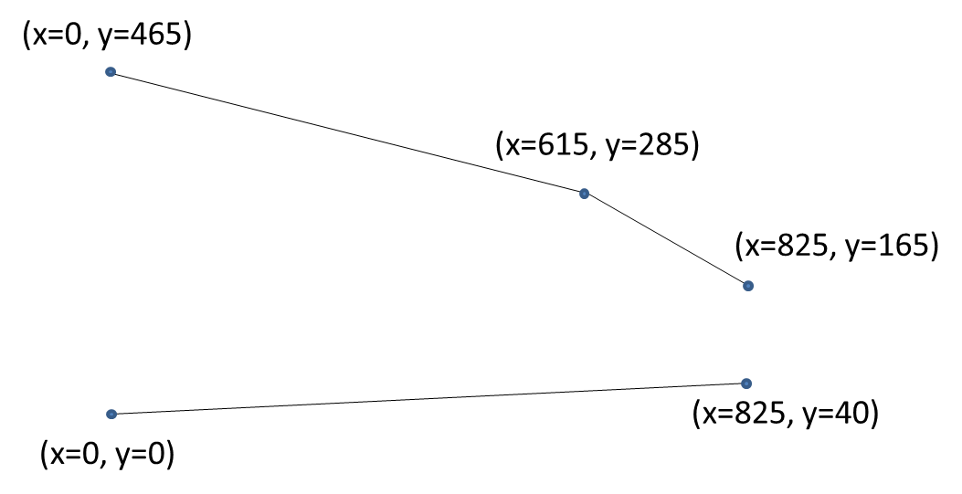

Entered into ACAD, this looks like:

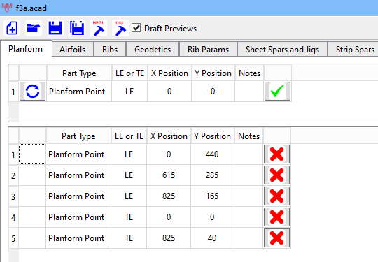

## Airfoil Definition

Airfoils can be loaded into ACAD in either Selig or Lednicer format files <http://airfoiltools.com/airfoil/index>. These are typically “.dat” files and there are many sources of them on the internet.

As a minimum, you need to specify the airfoil at the root and tip of the wing. But you can specify the airfoil at as many places as you desire; ACAD simply interpolates between the specified airfoils as it works across the wing.

For our F3A wing, we specify three airfoils:

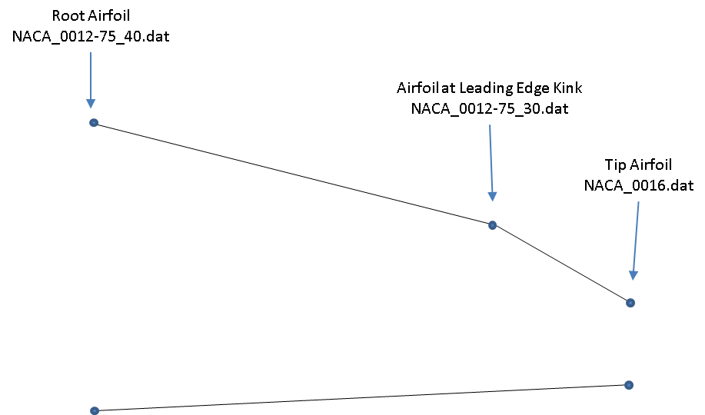

Entered into ACAD this looks like:

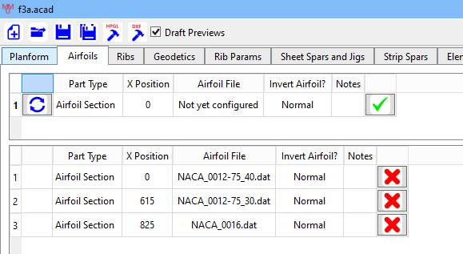

Note that the airfoils, once added, are stored within the .acad file for the design; there is no need to keep the .dat files if you don’t want to.

### Building a Wing Upside Down

It is possible to design a wing to be built upside down (for example, to allow undercarriage installation during the build). To do this, select the “Invert Airfoil” option **before selecting the Airfoil File.**

## Defining Ribs

Ribs are defined on the Ribs tab. The centreline of the rib stretches from an X position on the trailing edge to an X position on the leading edge; these X positions will be different if the rib is angled (often needed for root or tip ribs). The airfoil section of each rib is calculated automatically from the reference airfoils.

Although the rib centreline stretches from trailing to leading edge, the rib itself can be shortened by setting the leading and trailing edge widths. These are set individually for each rib and can be used to significantly shorten ribs where only a part rib is needed.

The *Rib Doubler*  part type is a shorthand way of quickly adding doublers to ribs. Each rib is automatically given an index when it is added to the design. When adding a doubler, you link it to the rib you want to “double” by entering that rib’s index in the “Linked To” field for the doubler. You also select whether you want the doubler to be placed to the left (root) or the right (tip) of the rib.

In our F3A example, doublers are used extensively. As shown below, rib 11 has three doublers on it, and one of those doublers (14) has another doubler on it (15).

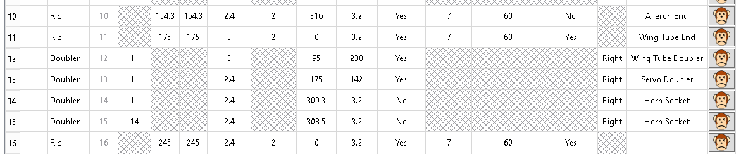

Setting the “Add Holes” parameter to “Yes” for a doubler will allow lightening holes to be drawn in the doubler and the rib where the doubler is attached; ACAD will ensure that a perimeter gluing area is created on both. When set to “No”, the doubler will have no holes and the rib will have no holes in the region where the doubler is attached.

Spacers are typically used for creating wing tip blocks and stand-offs for root ribs, as shown below. Spacers differ from normal ribs in that they do not interact with any other parts of the design so will not have spars slots etc. cut in them. If you want to oversize a spacer part to allow it to be sanded back to shape, set a *negative* value for the wing skin thickness.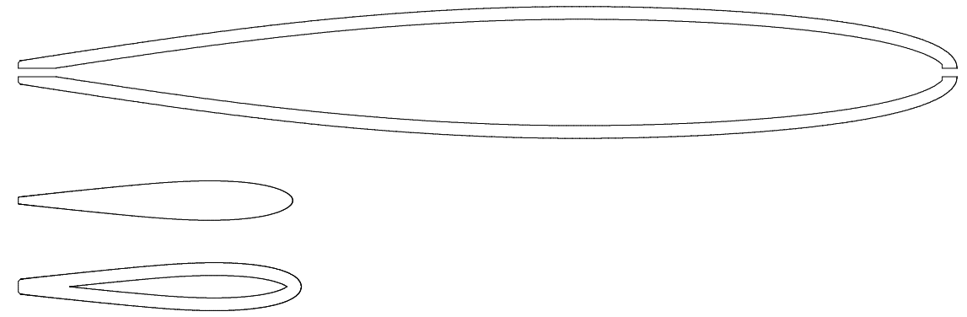

## Geodetics

ACAD can automatically generate chains of geodetic ribs, saving the user having to add lots of angled ribs. To add geodetic ribs:

* Define two lines in the planform, each crossing the ribs between which you want geodetic ribs.
* Decide whether the leftmost geodetic will start at the “top” line or the “bottom” line.

ACAD will then add one geodetic rib in each intersected rib bay. Geodetic ribs should not be defined such that they cross spar elements; if they do, the crossings will not be rendered.

Ribs

Geodetic definition lines

Geodetic Ribs

The F3A wing uses geodetic ribs to stiffen its ailerons:

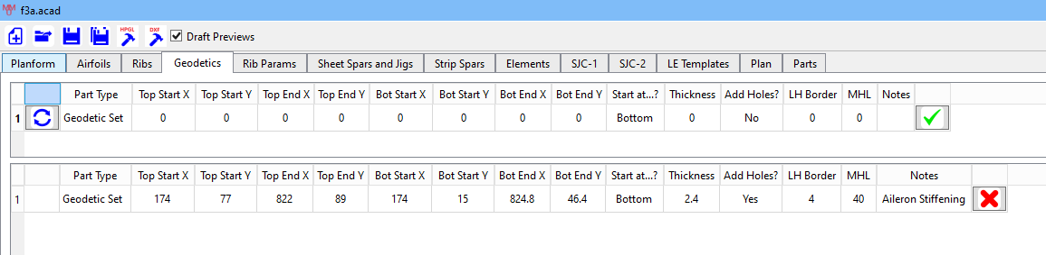

In the plan, this looks like this:



## Rib Parameters

This tab allows you to configure the trailing edge thickness, washout and manual keepout regions for one or more ribs.

### Washout

Washout can be applied across any parts of the wing using the *washout* tab.

The T28 example has no washout from the root to 634mm span; the washout then increases linearly to the tip. In ACAD, this looks like this:

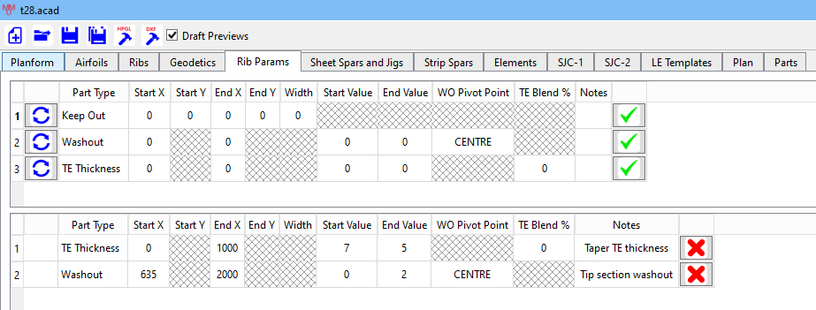

The final parameter of the *washout* command defines the pivot point about which the wing is twisted:

* Leading Edge
* Centre of the Chord
* Trailing Edge

Multiple washout commands can be used to vary the washout unevenly across the wing.

### Trailing Edge Thickness

Most airfoils have a defined trailing edge thickness of 0mm i.e., they come to a sharp edge. Normally, for building purposes, a thicker trailing edge is desired. The *teThickness* tab is used to set the TE thickness across parts of the wing. In general, you should set the teThickness to at least double the wing sheeting thickness.

The T28 example shown above has 7mm TE thickness at the root, decreasing to 5mm at the tip:

The blend parameter should be set to 0 to allow ACAD to decide how much of the chord to blend the thickness change over. Alternatively, you can enter a % of the chord to blend over.

Multiple *teThickness* commands can be used to set the thickness over different parts of the wing.

### Keepouts

Keepouts can be added to ribs to prevent ACAD from adding lightening holes in a specific part(s) of the rib(s). A keepout is added to each rib intersected by the line, with the keepout width set by the width parameter.

## Spars

There are several types of spar available in ACAD.

|  |  |  |
| --- | --- | --- |
| **sheetSpar** | A vertical sheet with slots in both ribs and the spar. The depth of the slot in the spar (and, hence, the rib) can be set, along with whether the spar should be inserted from above (slot will be in the bottom of the spar) or below. | |
|  | | |
| **jigSpar** | The same as a sheetSpar but includes material below the spar to stand it off the building board. In this way the spar is simultaneously used as a building jig. It is possible to request that ribs be tabbed rather than slotted. | |
|  | | |
| **boxSpar** | Comprises two rectangular spars, one at the top of the rib and one at the bottom, with sheet webs glued to the front and rear faces of the spars. ACAD will slot the ribs for the rectangular spars and draw the inter-spar webs. The webs are drawn vertically as they would normally have grain vertical. A maximum length for a web can be set and webs longer than this will be split into multiple parts. | |
|  | | |
| **HSpar** | Similar to a boxSpar but a single sheet web is inserted between the two rectangular spars. | |
| **H-Sheet Spar** | Similar to a HSpar, but instead of individual webs a single slotted sheet-spar is inserted between the rectangular strip spars. The sheet spar can be placed at the centre, front or rear edge of the rectangular spars. The rib will typically end up looking something like this: | |
| **Strip Spar** | A single rectangular spar aligned to either the top or bottom of the ribs. ACAD will slot the ribs for the spar. | |
| **ribSupport** | This is a sheet item, designed to support ribs above the building board as a jig. | |
|  | | |
| **ribTabs** | | Rib tabs are a traditional way of standing ribs off the building board during construction. The width of the tab can be specified; if it is greater than or equal to 10mm, marker squares will be added every 10mm to show where the rib outline should be. |
|  | | |

Spars are always straight and defined by the (x, y) coordinates of their start and end points in the planform. There are several options that can be used when defining spars

* **Remove Rib Material** (sheetSpar, jigSpar): This option is intended to allow spars to be used as false leading or trailing edges.
  + Set to No, this has no effect
  + Set to In Front, all rib material will be removed in front of the spar (a false leading edge)
  + Set to Behind, all rib material will be removed behind the spar (a false trailing edge)

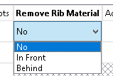

* **Tabs?** (jigSpar): Tabs, rather than slots, are typically used for false leading edges. Instead of slotting ribs and the spar, a central tab will be left on the rib with a matching hole in the spar. Start with a slot depth setting of around 35%.
* **Lightening Holes** (sheetSpar, jigSpar): Lightening holes are defined in the same way as for ribs.
* **Top or Bottom** (Strip Spar): Defines whether the spar is in the top of the ribs or the bottom.

## Elements (Tubular and Rectangular Bar)

Tubes and rectangular bars can be added to any part of the wing, although they only affect the drawing of ribs (if an element crosses a spar, it will not be drawn on the spar components).

Elements are defined in three dimensions i.e., the (x, y, z) coordinates are given for the start and end points of the element. See the section on “ Z or Height Coordinates”.

Tubes and bars are used to make holes for wing tubes, anti-rotation pegs, servo cables, servo bearers etc. The F3A wing has examples of all of these uses.

## Sheeting Jigs

#### SJC-1/2 and SJ Type 2

ACAD supports two ways of defining sheeting jigs. The first, using tabs SJC-1 and SJC-2, is deprecated and only maintained for the sake of updating old designs. The preferred method for new designs is SJ Type 2.

#### SJ Type 2

When defining a rib, you can select that you also require a sheeting jig part for that rib. These parts are assembled to create each half of a pair of jigs used to clamp the wing skins around the core whilst sheeting. A completed half consists of:

* The sheeting jig parts for the selected rib, positioned as the ribs are in the wing.
* Optional front and rear rectangular bars running through the jig parts. These are for clamping the top and bottom jigs together using pegs or similar (with the wing and its skins trapped in between). If you don’t want these bars, select End-Type “Simple”, otherwise select End Type “Clamp Bar”.
* Spars along the base of each jig, provided for strength and alignment. These are defined by adding a Jig Spar entity. They will be drawn slotted along with the jigs themselves so that they key together in the correct alignment. Two spars, roughly at the front and rear, will help align the jig parts with their matching ribs in the wing.
* Rectangular bars at the leading and trailing edges of the wing, provided to ensure the skin is firmly attached. The position of these can be tuned by selecting the “LE Bar Pos” and “TE Bar Pos”.

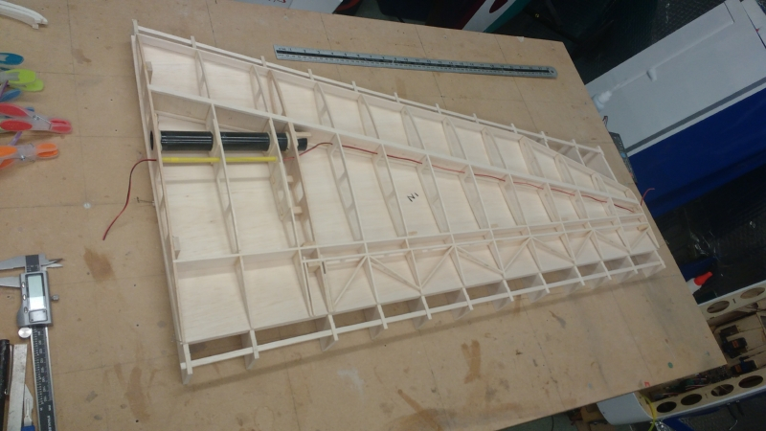

The image above shows a lower sheeting jig, with the lower wing skin and the wing core on top. The LE and TE clamping bars can be clearly seen.

The process for defining sheeting jigs is as follows:

1. Jig Configuration
   1. Define two lines in the planform, one typically 10mm in front of the leading edge and one typically 10mm behind the trailing edge. These lines tell ACAD where to start the clamping bar sections of each jig part; the 10mm gives some clearance between the wing and the jig part to make it easier to assemble and to allow the wing skins to be cut oversize. With complicated planforms, choose the lines so that they minimise the overall size of the jig parts.
   2. Define the dimensions of the LE and TE support bars. I often use a width of 3.5mm and a depth of 6mm, allowing them to cut from hard 1/8” balsa.
   3. Define the height of the rib chord line above the building board.
   4. Define the thickness of the jig material. I often use 3mm MDF.
   5. Select whether you want simple jig ends or jig ends with clamping bar slots.
   6. Commit the jig configuration entity.
2. For each jig bottom spar:
   1. Define the line in the planform
   2. Define the height of the spar. The spar and jigs will each be half-slotted where they cross.
   3. Define the material thickness.
   4. Commit the jig spar entity.

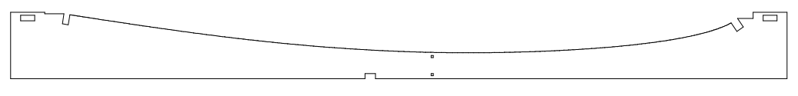

LE Clamping Bar

TE Support

LE Support

~10mm Clearance

TE Clamping Bar

## Alignment Dots

Alignment dots are used as a visual aid for aligning ribs on the sheeting jigs. Alignment dots are added along a line in the planform, with the squares of the requested dimension being added to the top and bottom of the rib and its corresponding sheeting jig part. They are added from the “Elements” tab.

Normally, I only add centre dots to the root and tip ribs/jig parts, using a square dimension of 1.1mm inset by 2.0mm. A root rib with alignment dots is shown below along with its sheeting jig part:

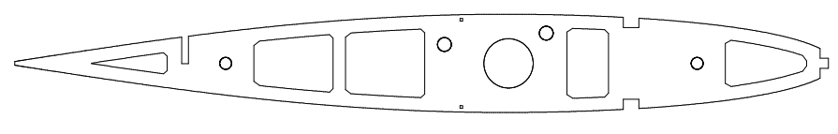



## Leading Edge Templates

These can be requested at any X position in the wing. The chamfered corner identifies the top of the template (useful when non-symmetric airfoils are used).

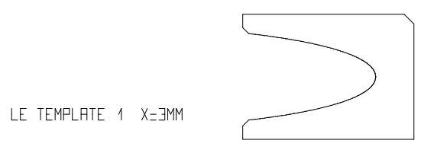

# The Example F3A Wing

The diagram below is the plan drawn by ACAD from the example wing file, annotated to show what features of ACAD were used for the components.

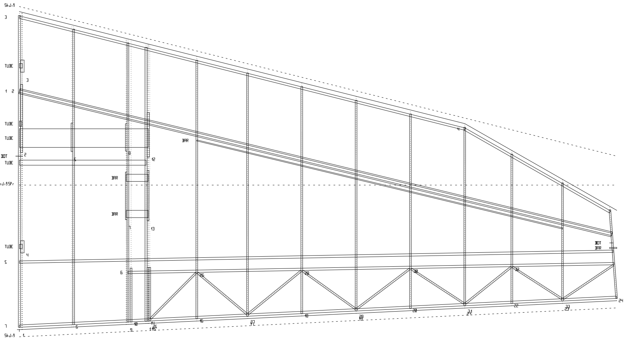

TE planform line

LE planform line

**elementBar** used for servo mounts

Tip rib is angled by setting different leading and trailing edge x positions  
for rear spar and aileron

**centreDots** used for alignment on tip and root ribs when sheeting  
for rear spar and aileron

**sheetSpar** used  
for rear spar and aileron

**jigSpar** used  
as a false leading edge and building jig

**ribSupport** used  
to support TE end of ribs during build

**elementTube** used for wing tube, cable guides and incidence pegs

**hSpar** used for main spar

**ribDoubler** examples

**sheetingJigConfig** defines   
boundary of sheeting jig parts

**geodetics** used  
to stiffen ailerons